CASE STUDY
AI-Powered Fraud Detection for Digital Payments
A Machine Learning Approach Modelled on PhonePe's Transaction Risk Environment
Prepared by: Ayushi, Angel, Arshita, Arpita, Ankita, Aniketa, Anchit
Course: BBA FinTech & AI
Focus Company: PhonePe | Industry: FinTech / Digital Payments
Academic Disclaimer: This is a student project built on a synthetic, illustrative dataset. It is not affiliated with, endorsed by, or built on proprietary data from PhonePe. It does not represent PhonePe's actual fraud-detection system.

Executive Summary
Digital payment platforms such as PhonePe process an extremely high volume of transactions every day, which makes them an attractive target for fraud through phishing, identity theft, compromised devices, and social engineering. This case study presents a machine-learning-based approach to flagging potentially fraudulent transactions in real time, allowing genuine transactions to pass through smoothly while suspicious ones are verified or blocked.
A Random Forest classification model was trained on a synthetic, academically generated dataset of 10,000 transactions, engineered to reflect realistic fraud-risk factors such as transaction amount, transaction frequency, device and location changes, failed login attempts, and account history. The trained model achieved an accuracy of 80.1% and an ROC-AUC score of 0.81 on unseen test data, and it was used to build a three-tier risk-scoring system (Low / Medium / High risk) that mirrors how a real payments platform might triage transactions for approval, verification, or investigation.
This document walks through the business problem, methodology, dataset, model results, and key findings, and closes with recommendations and limitations relevant to deploying such a system in a production fintech environment.

1. Business Problem
As digital payment adoption grows, so does the volume and sophistication of fraudulent activity on these platforms. Fraud can take many forms — phishing, identity theft, fraudulent accounts, suspicious beneficiaries, unauthorized transactions, compromised or malicious devices, and general misuse of the payment system.

Core Business Question
How can a digital payment platform identify potentially fraudulent transactions while still allowing genuine customers to complete their payments smoothly and without unnecessary friction?
The challenge lies in correctly distinguishing between three categories of transactions:
- Genuine transactions — should be approved instantly with no friction.
- Suspicious transactions — should be flagged for additional verification.
- Potentially fraudulent transactions — should be blocked or escalated for investigation.
An effective fraud-detection system needs to analyse transaction patterns and behavioural signals to produce a fast, data-driven risk assessment, so that the right action — approve, verify, or block — can be taken automatically and at scale.

Risk-Based Action Framework
Risk Level | Possible Action
Low Risk | Approve transaction automatically
Medium Risk | Warn the customer / request additional verification
High Risk | Block the transaction / escalate for investigation

Note: The exact risk-scoring formula and decisioning logic used internally by PhonePe are proprietary and not publicly available. This project therefore uses an academic, illustrative representation of a comparable fraud-detection process.

2. Project Objectives
- Detect potentially fraudulent digital-payment transactions using Machine Learning.
- Explore and understand the transaction-level features that are associated with fraud risk.
- Build and train a supervised ML classification model on transaction data.
- Evaluate the model's performance using appropriate classification metrics.
- Translate model output into a practical, three-tier risk-decision framework.
- Understand how AI/ML can realistically support real-time fraud detection at a digital payments company.

3. Dataset
Since proprietary PhonePe transaction data is not publicly available, a synthetic dataset of 10,000 transactions was programmatically generated for this project, designed to reflect realistic fraud-risk relationships. This dataset is for academic demonstration only and does not represent real PhonePe user data.

Dataset Features
Feature | Description
transaction_amount | Value of the transaction (₹), modelled with an exponential distribution typical of payment amounts
transactions_last_24h | Number of transactions made by the account in the past 24 hours
account_age_days | Age of the user's account in days (newer accounts carry higher risk)
new_device | Whether the transaction originated from a device not previously used (1 = yes)
new_recipient | Whether the payment is being sent to a new/unfamiliar recipient (1 = yes)
location_change | Whether the transaction location differs from the user's usual location (1 = yes)
failed_attempts | Number of failed login/payment attempts prior to this transaction
night_transaction | Whether the transaction occurred during typical night hours (1 = yes)
previous_fraud_reports | Whether the account has any prior fraud reports on record (1 = yes)
is_fraud (target) | Label indicating whether the transaction is fraudulent (1) or genuine (0)

Dataset Summary
Metric | Value
Total transactions | 10,000
Genuine transactions | 7,436 (74.36%)
Fraudulent transactions | 2,564 (25.64%)
Missing values | None
Duplicate records | None
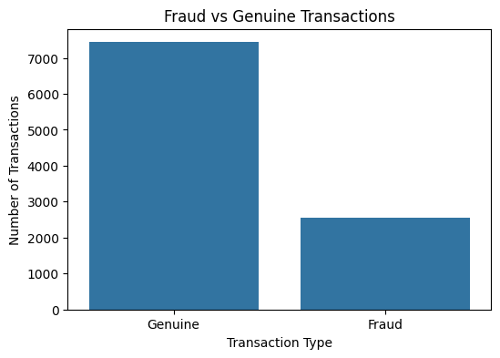
Figure 1: Distribution of genuine vs. fraudulent transactions in the training dataset

4. Data Cleaning & Preprocessing
Before model training, the dataset was checked for data-quality issues to ensure it was reliable for analysis:
- Missing values: none found across all 10 columns.
- Duplicate records: none found.
- Data types: all numeric (int/float), consistent with model requirements — no encoding needed.
- Basic statistics were reviewed to confirm value ranges were realistic (e.g., no negative amounts or ages).

Preprocessing Steps
- Input features (X) were separated from the target variable (y = is_fraud).
- The dataset was split into training (80%, 8,000 records) and testing (20%, 2,000 records) sets.
- Stratified sampling was used on the split to preserve the same fraud/genuine ratio in both sets.
- A fixed random seed (42) was used throughout to ensure the results are reproducible.

5. Model Building
A Random Forest Classifier was selected for this task because it handles non-linear relationships well, is robust to outliers, and provides interpretable feature-importance scores — useful for explaining fraud decisions to stakeholders.

Model Configuration
Parameter | Value | Purpose
Algorithm | Random Forest Classifier | Ensemble of decision trees for robust classification
n_estimators | 150 | Number of trees in the forest
max_depth | 12 | Controls tree complexity to reduce overfitting
class_weight | balanced | Compensates for the fraud class being a minority (~26%)
random_state | 42 | Ensures reproducible results

6. Model Evaluation

Overall Performance
Metric | Score
Accuracy | 80.05%
ROC-AUC | 0.8101

Classification Report
Class | Precision | Recall | F1-Score | Support
Genuine (0) | 0.86 | 0.88 | 0.87 | 1,487
Fraud (1) | 0.62 | 0.57 | 0.59 | 513
Weighted Avg | 0.80 | 0.80 | 0.80 | 2,000
The model performs strongly on genuine transactions (87% F1-score) and reasonably on the harder fraud-detection task (59% F1-score), which is expected given fraud is the minority class and inherently harder to separate cleanly. In a production setting, this recall/precision trade-off would be tuned based on the platform's tolerance for false positives (blocking genuine users) versus false negatives (missing real fraud).

Confusion Matrix
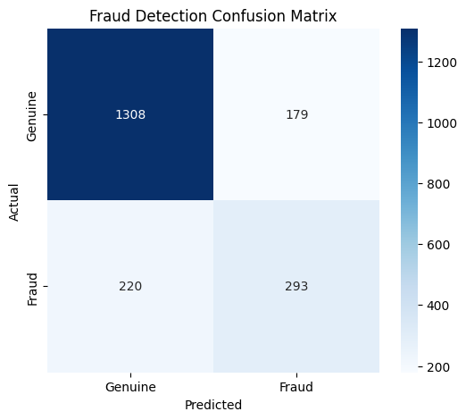
Figure 2: Confusion matrix on the 2,000-transaction test set
Out of 2,000 test transactions, the model correctly identified 1,308 genuine transactions and 293 fraudulent transactions. It incorrectly flagged 179 genuine transactions as fraud (false positives) and missed 220 fraudulent transactions (false negatives) — a realistic outcome for a first-pass academic model that would typically be refined further before production use.

7. Feature Importance
Understanding which features drive the model's fraud predictions is essential for explainability and for prioritising which signals a real fraud-monitoring team should focus on.
Rank | Feature | Importance
1 | transaction_amount | 46.9%
2 | account_age_days | 17.0%
3 | transactions_last_24h | 8.7%
4 | failed_attempts | 8.2%
5 | previous_fraud_reports | 5.2%
6 | new_recipient | 4.0%
7 | location_change | 3.8%
8 | new_device | 3.7%
9 | night_transaction | 2.5%
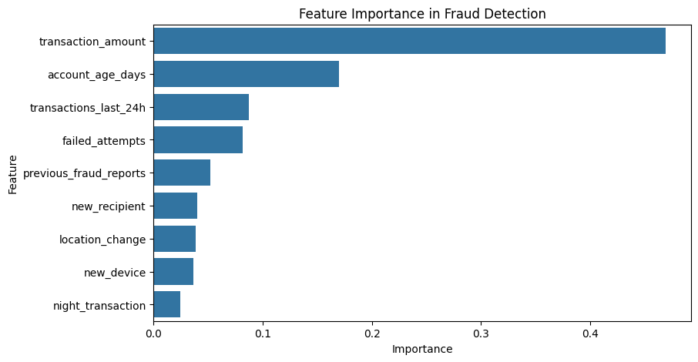
Figure 3: Relative feature importance from the trained Random Forest model
Transaction amount and account age together account for nearly two-thirds of the model's decision-making, suggesting that large transactions from newer or less-established accounts are the strongest early-warning signals in this dataset — a pattern that aligns with common real-world fraud typologies.

8. Risk-Scoring & Decision System
The model's fraud probability output was converted into a simple, three-tier decision system that mirrors how a payments platform might automate its response to risk:
Fraud Probability | Risk Level | Decision
Below 30% | Low Risk | APPROVE — transaction proceeds automatically
30% – 70% | Medium Risk | VERIFY — additional authentication requested
Above 70% | High Risk | BLOCK / INVESTIGATE — transaction held for review

Sample Transaction Tests
The trained model and decision function were tested against two contrasting scenarios to validate real-world behaviour:
Scenario | Amount | Key Risk Signals | Fraud Probability | Decision
High-risk transaction | ₹30,000 | New device, new recipient, location change, 4 failed attempts, night transaction, 20-day-old account, 15 transactions in 24h | 81.33% | HIGH RISK — BLOCK / INVESTIGATE
Low-risk transaction | ₹800 | Established device and recipient, no location change, no failed attempts, 900-day-old account, 2 transactions in 24h | 9.68% | LOW RISK — APPROVE
These results demonstrate that the model correctly separates a clearly risky transaction pattern from a clearly normal one, giving confidence that the underlying risk signals are being learned sensibly even on synthetic data.

9. Key Findings
- The model achieved 80.05% accuracy and a ROC-AUC of 0.81, indicating reasonably strong discriminative ability between genuine and fraudulent transactions.
- Transaction amount and account age are the two most influential predictors of fraud risk in this dataset, together contributing nearly 64% of the model's decision weight.
- Behavioural signals — new device, new recipient, location change, and failed attempts — meaningfully add to fraud risk even though individually they carry less weight than amount and account age.
- The three-tier risk framework (Approve / Verify / Block) offers a practical way to translate a probability score into an operational decision without requiring a human to review every transaction.
- Precision and recall for the fraud class (62% / 57%) indicate the model would benefit from further tuning — such as threshold adjustment, additional features, or more advanced algorithms — before any real-world deployment.

10. Recommendations
- Incorporate additional real-world signals such as device fingerprinting, IP/geolocation velocity, merchant category, and transaction network graphs (linked accounts) to improve fraud recall.
- Introduce a feedback loop where confirmed fraud/genuine outcomes are fed back into the model to enable continuous retraining and adaptation to new fraud patterns.
- Calibrate the Medium/High risk thresholds based on the platform's actual cost trade-off between blocking genuine users (customer friction) and missing real fraud (financial loss).
- Combine the ML model with rule-based checks (e.g., hard limits on new accounts) for an added layer of protection during the model's early deployment phase.
- Pilot the system on a small transaction segment first, monitor false-positive rates closely, and expand gradually with human-in-the-loop review for medium-risk cases.

11. Limitations & Academic Disclaimer
- This project uses a synthetic, programmatically generated dataset — it does not contain, reference, or approximate any real PhonePe customer or transaction data.
- The risk-scoring thresholds and decision logic are illustrative and created for academic purposes; they are not PhonePe's actual proprietary fraud-detection methodology.
- Real-world fraud detection systems typically combine ML models with rule engines, device intelligence, graph analysis, and human review — this project demonstrates only the ML classification component.
- Model performance on synthetic data does not guarantee similar performance on real transaction data, which is typically noisier and more adversarial (fraudsters actively adapt to detection systems).
This project is intended purely as an academic demonstration of how Machine Learning can support fraud detection in the digital payments industry.

12. Conclusion
This project demonstrates an end-to-end Machine Learning workflow for digital-payment fraud detection — from synthetic data generation and cleaning, through model training and evaluation, to a practical risk-decision framework and live transaction testing.

Overall Process
Data → Preprocessing → ML Model → Prediction → Evaluation → Fraud Decision
With an accuracy of 80% and an ROC-AUC of 0.81, the Random Forest model shows that even a relatively simple, well-engineered set of transaction features can meaningfully separate genuine from fraudulent behaviour. The broader goal — improving security, reducing fraud losses, and supporting safer digital payments — is one that AI/ML is well positioned to support as part of a larger, multi-layered fraud-prevention strategy at companies like PhonePe.

